HELP FOR MINUSXL

## Add Spreadsheet

* In order to add a new spreadsheet you have to go to Insert->Spreadsheet
* Then ,you can insert the desired number of rows ,columns and a name. If you press OK without filling a textfield , then a default spreadsheet is created.

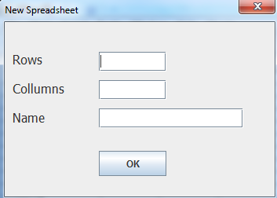

## Delete Spreadsheet

* In order to delete a spreadsheet ,you have to go to Window->Close Spreadsheet.
* Then ,you have to insert the number of the spreadsheet that you want to delete .

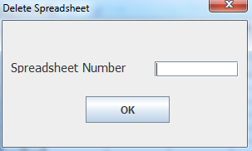

* Press OK

## New Workbook

* In order to create a new workbook you have to go to File->New Workbook
* Then ,insert the name of the new workbook.

### Save Workbook

* In order to save workbook you have to go to File->Save Workbook.

### Load Spreadsheet

* In order to load a spreadsheet you have to go to File->Load.
* Then insert the name of the spreadsheet that you want to load.

### Save Spreadsheet

* In order to save a spreadsheet you have to go to File->Save.

## Line Chart

* In order to make a Line chart you have to use a spreadsheet of the following format :

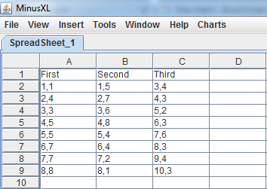

* Press Charts->LineChart :

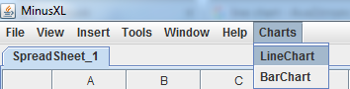

* Give a name for the title ,the x Axis and the y Axis :

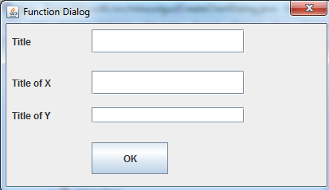

* And now you got your line chart!

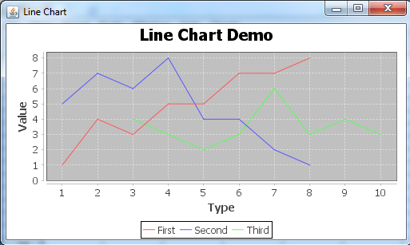

## Bar Chart

* In order to make a Line chart you have to use a spreadsheet of the following format :

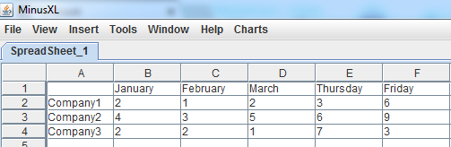

* Press Charts->BarChart :

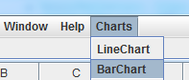

* Give a name for the title ,the x Axis and the y Axis :



* And now you got your bar chart!

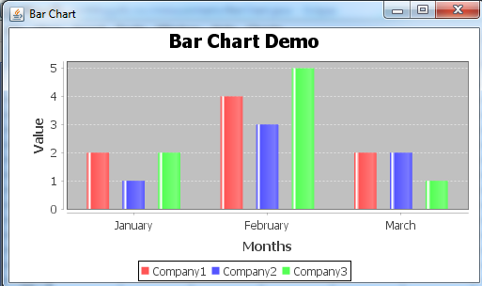

### Functions

The available functions are : abs ,cos ,sin ,tan ,pow ,sum ,mult ,log ,log10 ,and ,or ,not ,xor ,max ,

min ,mean ,median ,Stddev , Concat , includes , trim , remove .

* In order to use a function you have to go to Tools->Functions 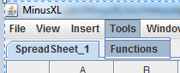
* Then ,you have to give the coordinates of the input cells,the name of the function and the output cell.

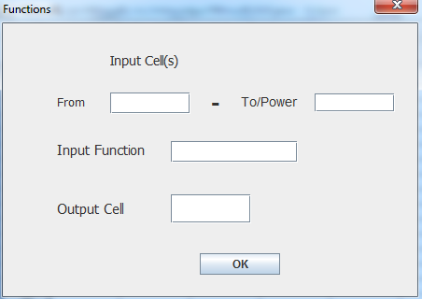

* If a function requires only one input cell ,all you have to do is insert the coordinates of the same cell into both textfields(From and To) .

* Press OK